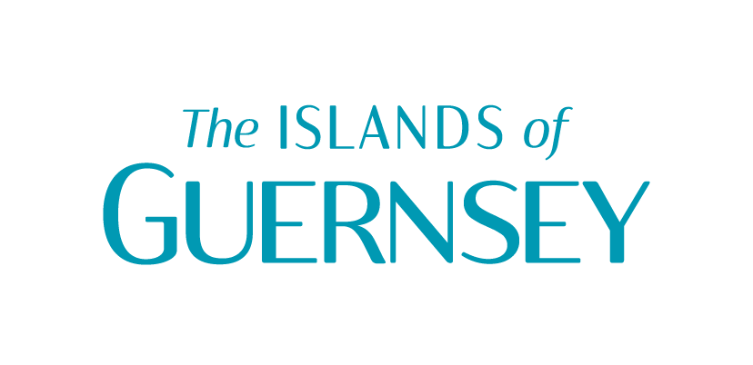
Product Development form
Please complete the below form and either return to Sir Charles Frossard House, for the attention of Jo Ferguson or email a copy to jo.ferguson@gov.gg.
- What is your business name?
- Please share what you are calling your Heritage themed Product/Service?
- What are the names of the other businesses you are collaborating with for this product/service?
- Please describe what the product/service offering is and how you have ingrained the Heritage theme? (Between 50-100 words)
- Optional: For a customer who can visit anywhere else in the world, tell us why they should visit your business and purchase your product/service?
- What date(s) will you be offering this product/service? (Is it a one off event or a limited period event?)
- How does a customer find out more or book/buy this product/service? (e.g. website, email, or telephone number? Help us make it easy for them to buy/book)
- How much is your product/service?
- What is the maximum group/booking size? (e.g. up to 10 per tour/table or up to 30 etc?)
- Is it accessible? (e.g. wheelchair users, hard of hearing, visually impaired?)
- Who is the best contact for us to coordinate marketing of your product/service on the Visit Guernsey media channels? (This could be for photos, product descriptions, quotes or perhaps a video)

